

EvoScan MapTracer Tutorial

Contents

EvoScan MapTracer Tutorial 1
1 What is MapTracer? 2
2 Opening MapTracer-screen 3
3 Getting started with MapTracer-screen 4
4 Parts of MapTracer-screen 5
4.1 Title Bar 5
4.2 Limit Value Selection 5
4.3 Data Values Selection 5
4.4 Load Selection 6
4.5 RPM Selection 6
4.6 Log Tab 6
4.7 Favourites Selection 6
4.8 Log Item Selection 6
4.9 Save ROM 6
4.10 Load Log 7
4.11 Log Grid 7
4.12 ROM Grid 7

1 What is MapTracer?

EvoScan MapTracer is a tool for viewing Log-files, viewing and editing ROM-files and comparing these two in an easy, visual way.

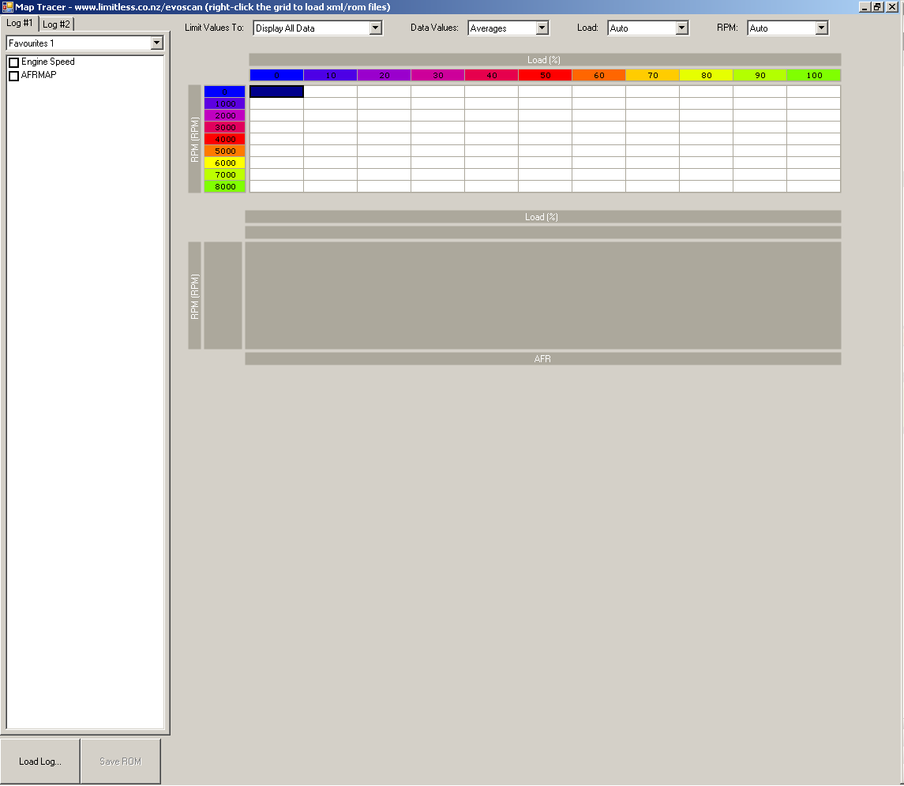
Img1.1: MapTracer-screen

2 Opening MapTracer-screen

On EvoScan main screen open Graphs & MapTracer menu and choose Analyse .csv Log File – Map Tracer – Load, Fuel and Timing. After that a file browser pops up for you to choose the log file you wish to analyse. If you have your log file opened in another application, you should close it before opening it with EvoScan.
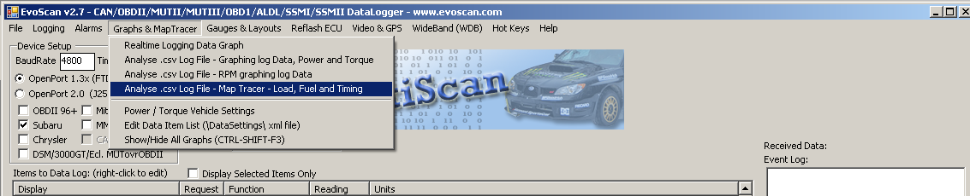
Img2.1: Opening MapTracer-screen on EvoScan main screen
MapTracer-screen can also be opened from EvoScan Graph –screen by clicking Map Tracer –button.
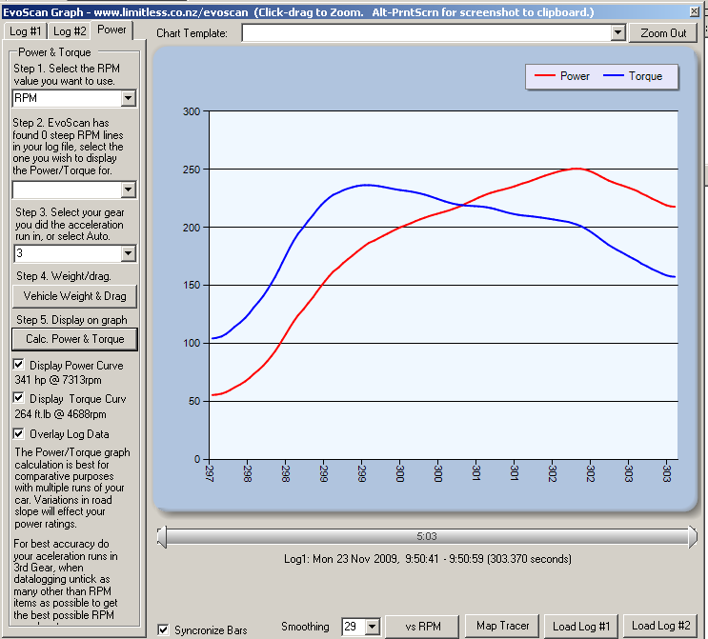
Img2.2: Opening MapTracer-screen on EvoScan Graph –screen

3 Getting started with MapTracer-screen

To get started with MapTracer-screen load a ROM (hex/bin file) by right-clicking bottom grid and choosing ‘Load HEX and XML Files…’. When loading a ROM file for the first time, EvoScan will try and find your definition file by looking for it in the folder where the ROM file is located, EvoScan\ROMS-folder and EcuFlash\rommetdata-folder. If definition file is not found in these locations, you can select it manually.
After you have loaded a ROM once, EvoScan will remember last opened files (both ROM and definition file) and automatically load them for you. If you open MapTracer-screen from Graph-screen the log files loaded on that screen will be automatically loaded on MapTracer-screen as well.
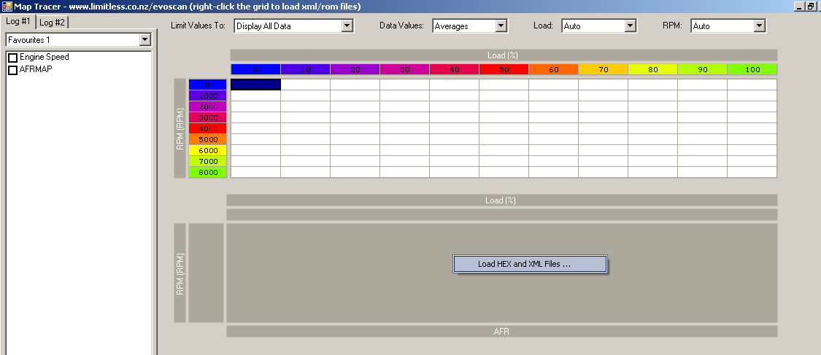
Img3.1: Loading ROM-files

4 Parts of MapTracer-screen
2 Limit Value Selection
3 Data Values Selection
4 Load Selection
5 RPM Selection
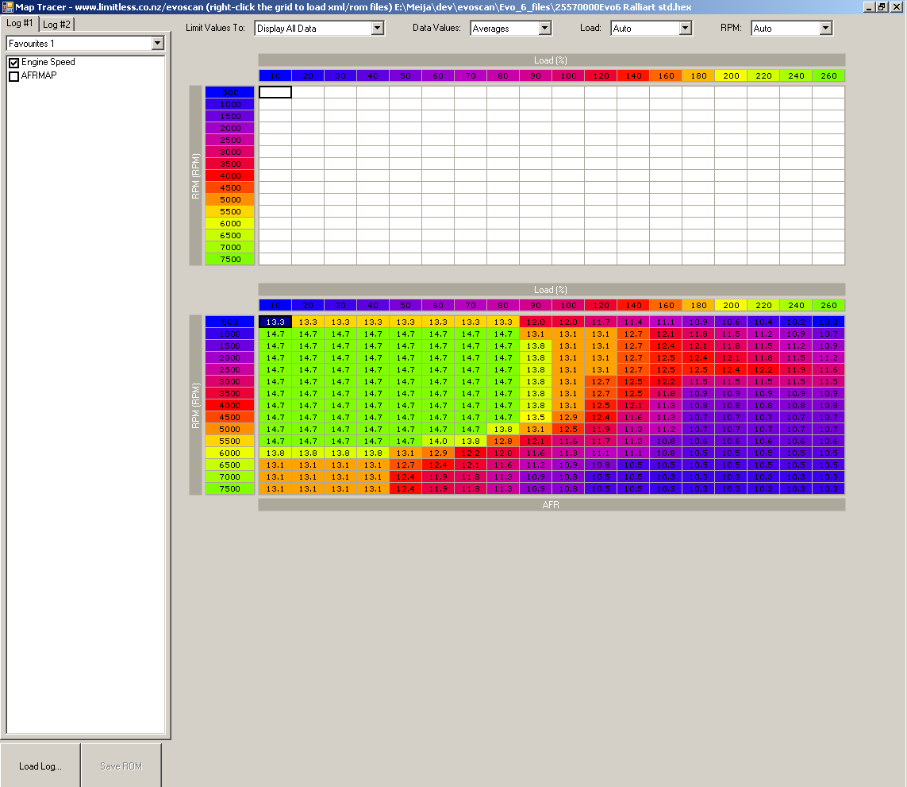
1 Title Bar
6 Log Tab
11 Log Grid
7 Favourites Selection
8 Log Item Selection
12 ROM Grid
9 Save ROM -button

10 Load Log-button

Img4.1: Different parts of MapTracer-screen

4.1 Title Bar
Title Bar shows the path and name of the loaded ROM if ROM is loaded. It also shows an asterisk (*) after the filename if there are any unsaved changes.

4.2 Limit Value Selection
Limit value-combo box lists all the runs found in the log file and you can choose to only show data from certain runs or choose ‘Display all data’ to show all.

4.3 Data Values Selection
Data Values –combo box has four options; Averages, Minimums, Maximums and Count. This selection determines what kinds of values are shown on Log Grid i.e. Averages-selection shows an average of values on that RPM-Load range. In the image below Averages is selected and a tooltip for the cell Load20, RPM 2000 is visible. In the tooltip you can see all the values with Load 20-30 and RPM 2000-2500. With the selection Averages, average (2010.4) of these three values is shown on the grid. Count would show “3”, Maximums “2031.3” and Minimums “2000.0”.
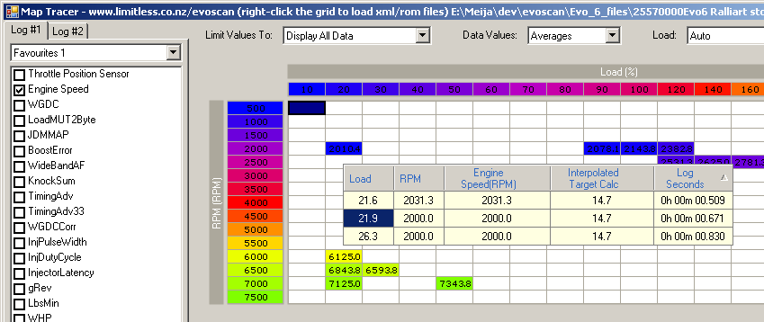
Tooltip visible for this cell
Img4.2: Data Values Selection on Log Grid

4.4 Load Selection
Load-combo box lists all load items found in the log file and a default value Auto which uses the following load items: Load, LoadMUT2Byte, LoadCalc, EngineLoad, AbsoluteLoad, Load160, ECULoad, Load11bit4, Load1B, AbsLoad, AccLoad, LoadMIVEC, LoadLowIATSTiming and LoadFuel. This selection determines which values to use on x-axis load values.

4.5 RPM Selection
RPM-combo box lists all RPM items found in the log file and a default value Auto which uses the following RPM items: RPMMUT2Byte, 2ByteRPM and RPM. This selection determines which values to use on y-axis RPM values.

4.6 Log Tab
When opening MapTracer-screen from EvoScan Graph-screen the log files from that screen are loaded on MapTracer. If Log #2 was loaded on Graph-screen it will be viewable on MapTracer-screen as well by selecting Log #2 tab.

4.7 Favourites Selection
You can save your favourite item selections and use them by changing the selection on the Favourites-combo box. You can save separate favourites for both log files. Favourites are saved automatically when MapTracer is closed. Favourites are the same for Cross Chart, Power Graph and MapTracer –screens, the only difference being that on MapTracer-screen you can only select one item where as on the other screens you can select multiple items.

4.8 Log Item Selection
On the Log Item Selection list you can see all the items found in your log file. Select the one you want to view on RPM Grid.

4.9 Save ROM
You can edit your ROM file on ROM Grid and save it with this button. Button is only enabled when there are unsaved changes. You can either replace the original file or save your changes in a new file.

4.10 Load Log
Load Log button lets you load another Log file on to the Log Grid.

4.11 Log Grid
Log Grid shows values from the Log file. The values are not editable. When you place the mouse over a specific cell a tooltip pops up with additional info on the cell. You can copy values from the grid onto the clipboard by selecting a cell or area and pressing Control+c key combination. You can navigate the grid with arrow keys and select an area by holding down shift when pressing arrow keys. Log and ROM grids are synchronised so whenever you change the selection on one grid the selection on the other grid will be changed too.

4.12 ROM Grid
ROM grid is a 3d presentation of the ROM file loaded with RPM on the Y axis and Load on the X axis. Cells are colour coded so that the cells with higher values have different shades of blue/purple background, cells with medium values have different shades of red/orange background and the cells with lower values have different shades of yellow/green background. Colour coding makes it easy to see any deviant values. Log and ROM grids are synchronised so whenever you change the selection on one grid the selection on the other grid will be changed too.

4.12.1 Editing ROM
You can edit values of one or more selected cells with following keys:
= open a dialog where you can enter a new value (decimal or hex) or formula
+, ] increment
-, [ decrement
Arithmetic operations to be used in formulas are additions, subtractions, multiplication, divisions, power and negations. You can copy values from the grid onto the clipboard by selecting a cell or area and pressing Control+c key combination. You can navigate the grid with arrow keys and select an area by holding down shift when pressing arrow keys. You can paste values copied to the clipboard from the ROM Grid as well as from other programs (MS Excel, EcuFlash etc) by pressing Control+v. After you have modified values on the grid, you can save them by pressing Save ROM button. You will also be prompted to save any unsaved changes when closing the screen or loading a new ROM file.

4.12.2 ROM Grid Context Menu
You can open the ROM Grid context menu by right clicking the grid. On the context menu, you can load another ROM file by selecting ‘Load HEX and XML Files…’. If you have unsaved changes on your current ROM file you will be prompted to save them. The context menu also lists the types of available maps i.e. high octane fuel map, high octane ignition map etc. Map type selection is saved when the form is closed so if you typically want to view High Octane Ignition Map you don’t have to select it every time.
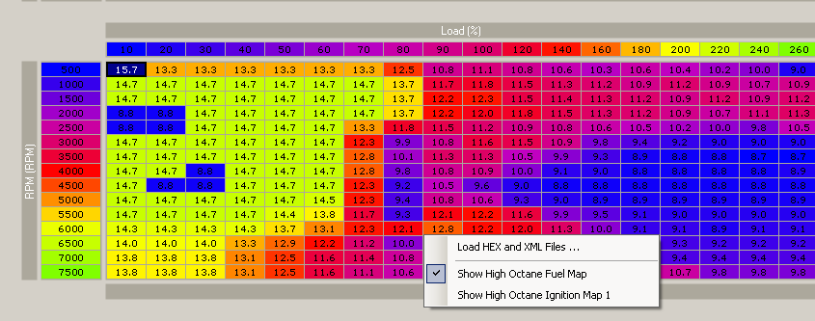
Img4.3: ROM Grid Context Menu

